**Planul geometric**

**al bunului imobil cu numărul cadastral 5359210.228**

Anexă nr. 2 la decizia Consiliului raional

**3**

**4**

**.228**

**5**

**6**

**2**

**7** **8**

**1**

Hîncești nr. _____ din ___________ 2025

*Amplasamentul* *bunului* 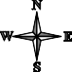

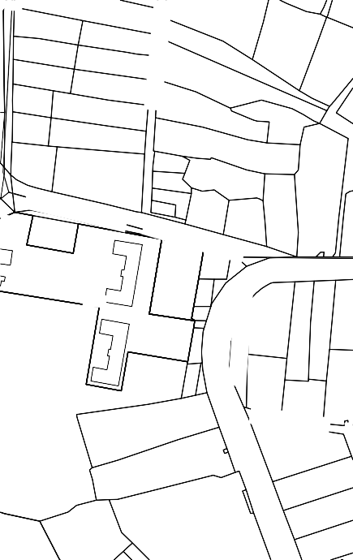

0228

0220

***str.*** ***?tefan*** ***cel*** ***Mare***

***str.*** ***?tefan*** ***cel*** ***Mare***

***st***

***str.*** ***?tefan*** ***cel*** ***Mare***

***str.*** ***N.*** ***Testemi?eanu***

***r***

*0228* *-* *numărul* *terenului*

***str.*** ***Tineretului***

***st***

Caracteristicile tehnice ale bunului imobil

|  |  |  |  |  |
| --- | --- | --- | --- | --- |
| **Numar_cadastral** | **Tipul_bunului** | **Suprafata** | **Destinatia** | **Mod_de_folosinta** |

|  |  |  |  |  |
| --- | --- | --- | --- | --- |
| 5359210.228 | Teren | 0.2132 ha | Terenuri destinate constructiilor si amenajarilor | Terenuri pentru amplasarea constructiilor publice |

**CATALOGUL** **COORDONATELOR**

# bunului imobil (format prin separare) cu numarul cadastral 5359210.228

|  |  |  |  |  |  |  |
| --- | --- | --- | --- | --- | --- | --- |
| **Punctul** | **Coordonata_X** | **Coordonata_Y** | **Tipul_punctului** | **Hotarul** | **Distanta** | **Tipul_hotarului** |

|  |  |  |  |  |  |  |
| --- | --- | --- | --- | --- | --- | --- |
| 1 | 208.287,6338 | 176.586,4404 | general | 1-2 | 37,53 | general |
| 2 | 208.250,5064 | 176.591,9534 | general | 2-3 | 61,68 | general |
| 3 | 208.260,7336 | 176.652,7842 | general | 3-4 | 35,10 | general |
| 4 | 208.295,2580 | 176.646,4540 | general | 4-5 | 26,49 | general |
| 5 | 208.290,6680 | 176.620,3666 | general | 5-6 | 22,60 | general |
| 6 | 208.286,7518 | 176.598,1086 | general | 6-7 | 10,00 | general |
| 7 | 208.285,0190 | 176.588,2600 | general | 7-8 | 3,10 | general |
| 8 | 208.287,6710 | 176.586,6550 | general | 8-1 | 0,22 | general |

*Coordonat:*

**Președintele raionului Hîncești** _________________ **Iurie LEVINSCHI**

**Șeful Serviciului relații**

**funciare și cadastru** _________________ **Victor RACHIU**

*Contrasemnează:*

**Secretarul Consiliului raional Hîncești** _________________ **Elena MORARU TOMA**